**Custom Generated Key**

Step 1- Launch an instance, and connect to browser.

Step 2 – Go to your home directory – pwd -> ls -a

We have .ssh directory read that directory

cat .ssh -> authoried key -> cat authorized key

Under this we have our public key & at last the name of our private key (newkey)

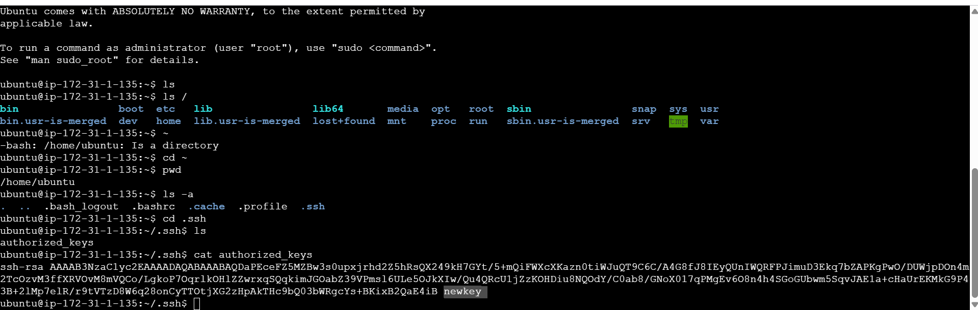

Step 3 – Now we generate one public key under authorized key on our home dir

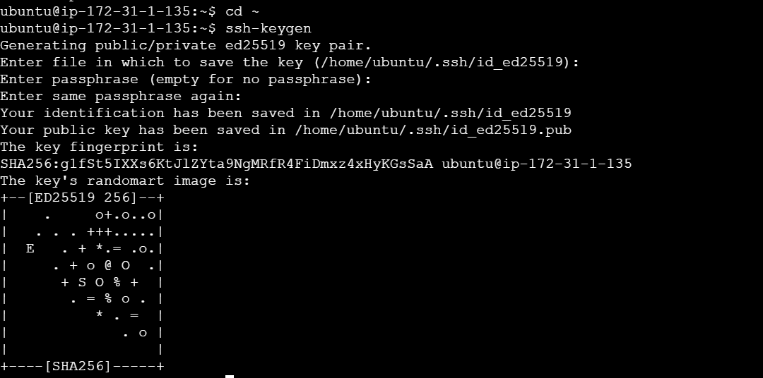

Step 4 – go to again .ssh

We can see both public & public keys generated, public key has .pub ext.

Now we copy our public key and paste it into authorized key folder.

And copy our private key at our system.

Then follow same procedure as we connect to client by using our Keys.

